Output Assignment 7

/* 1.Rank employees by their total sales(Total sales = Total no of orders handled, JOIN employees and orders table) */

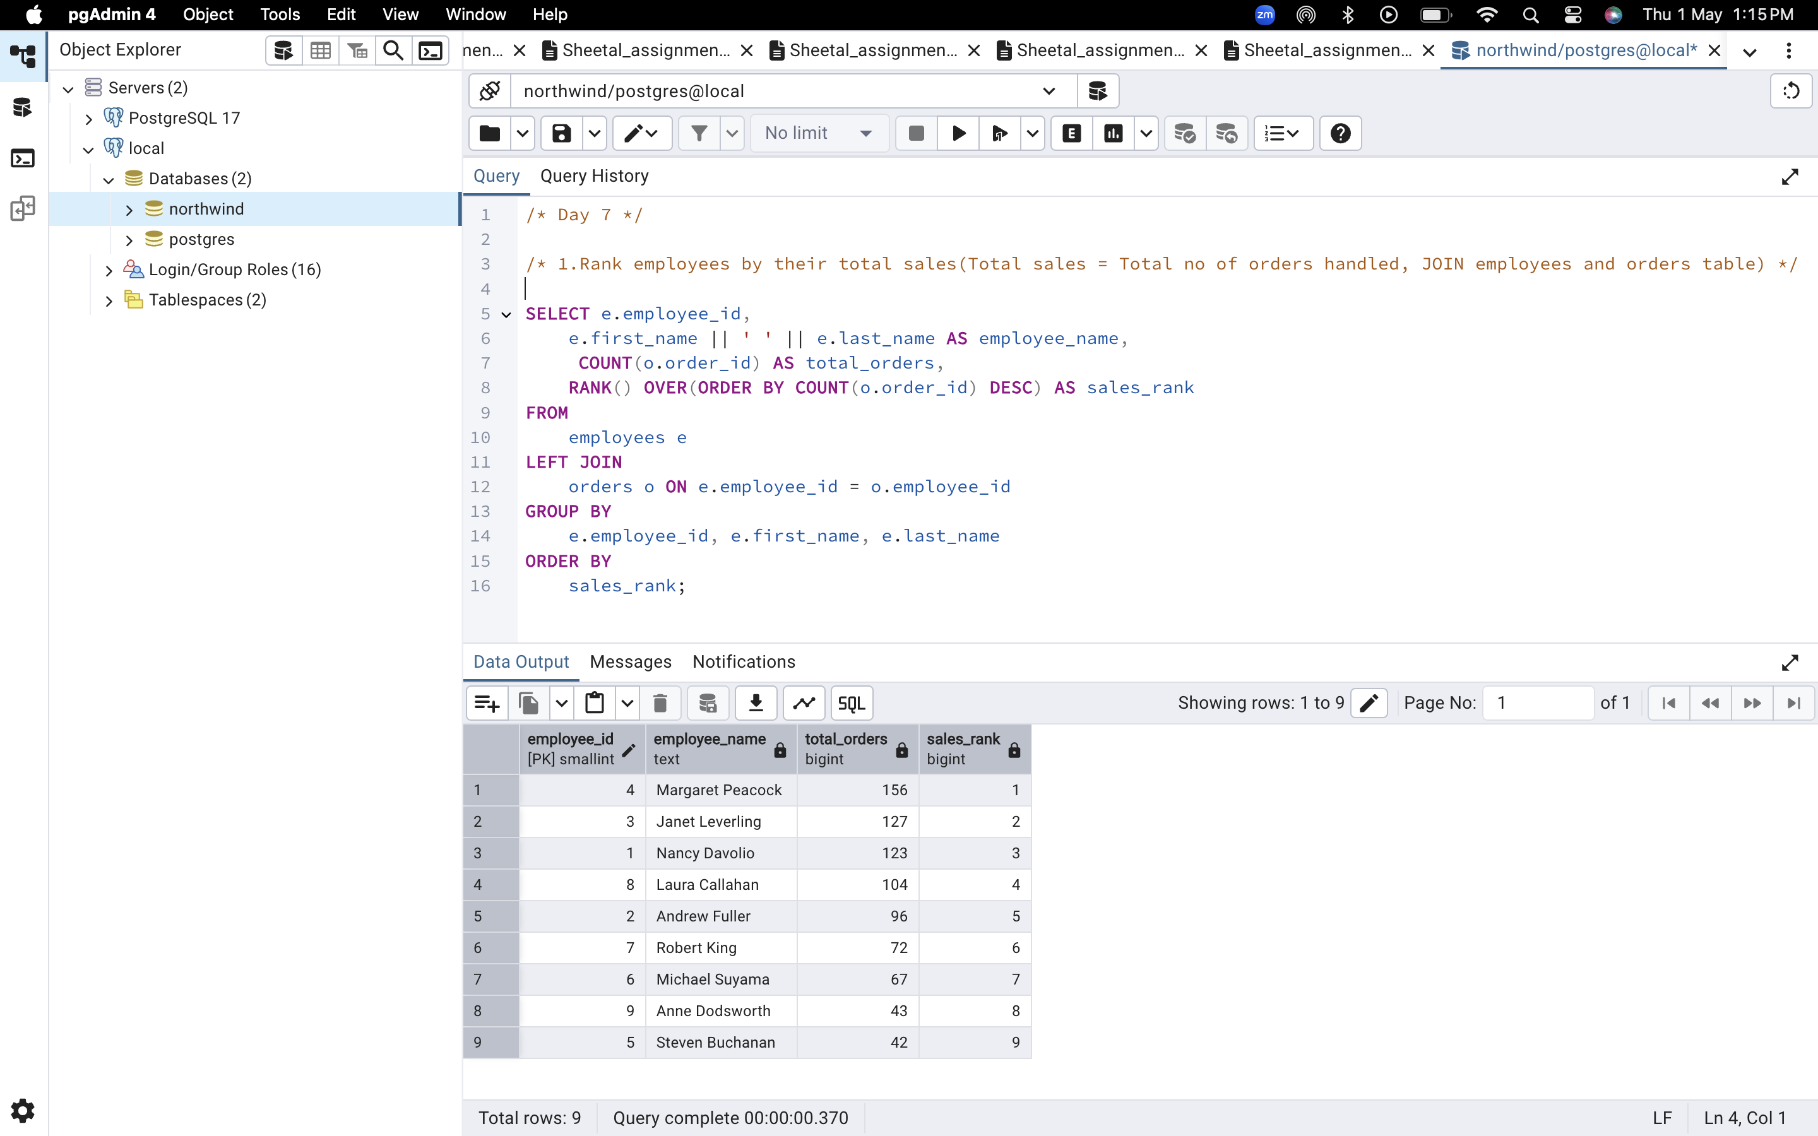

2.Compare current order's freight with previous and next order for each customer. (Display order_id, customer_id, order_date, freight, Use lead(freight) and lag(freight).

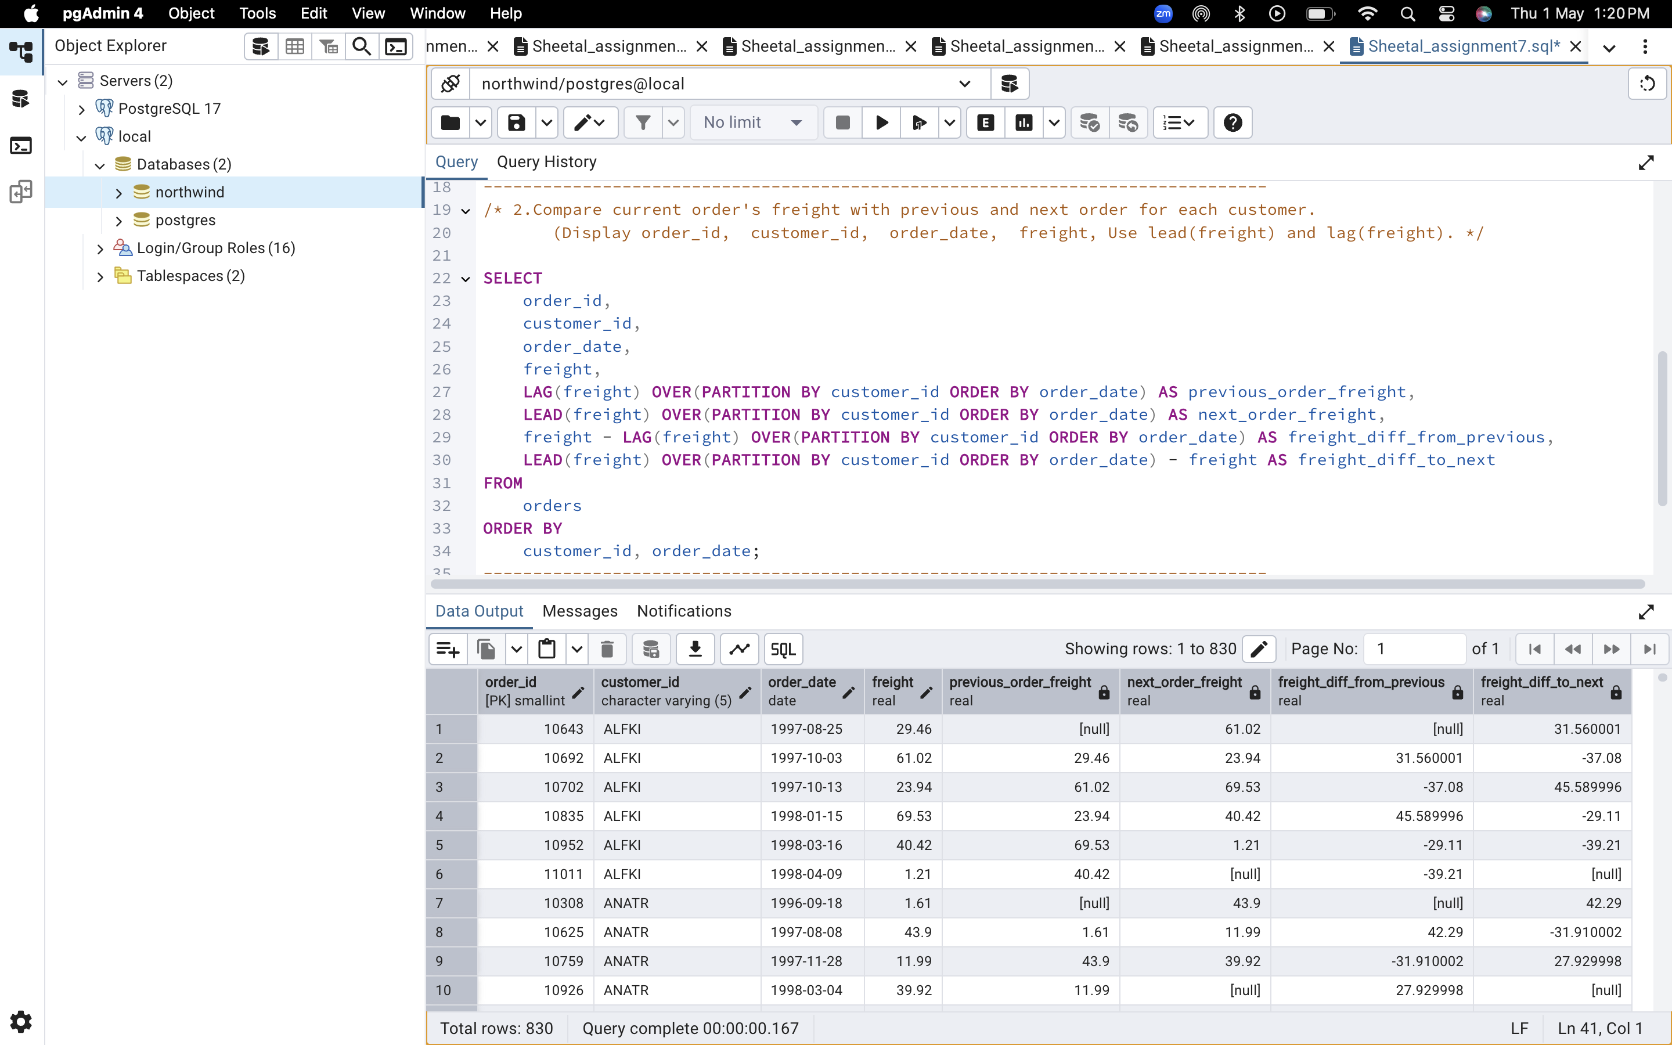

/* 3. Show products and their price categories, product count in each category, avg price: (HINT: Create a CTE which should have price_category definition: WHEN unit_price < 20 THEN 'Low Price' WHEN unit_price < 50 THEN 'Medium Price' ELSE 'High Price' In the main query display: price_category, product_count in each price_category, ROUND(AVG(unit_price)::numeric, 2) as avg_price) */

